Project Design Phase
Solution Architecture

Date | 6 July 2026
Team ID
Project Name | CAB BOOKING
Maximum Marks | 4 Marks

Solution Architecture:
The RideReady Cab Booking System is developed using the MERN Stack (MongoDB, Express.js, React.js, and Node.js). It provides a secure and efficient platform for passengers and drivers. The architecture follows a client-server model where the React frontend communicates with the Express/Node.js backend through REST APIs, while MongoDB stores all application data.
Goals
- Provide a fast and secure cab booking platform.
- Enable user and driver authentication.
- Manage ride booking and ride history.
- Store user, driver, and ride information securely.
- Build a scalable and responsive application.

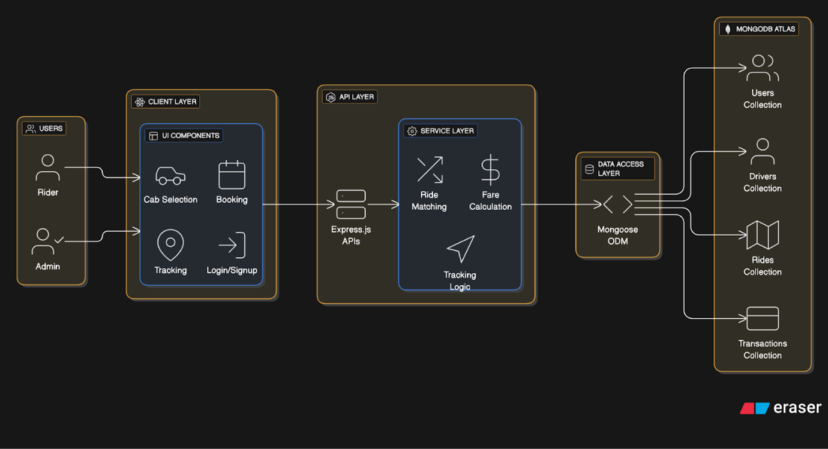
Example - Solution Architecture Diagram:

Figure 1: Solution Architecture of RideReady – Cab Booking System
Reference: https://aws.amazon.com/blogs/industries/voice-applications-in-clinical-research-powered-by-ai-on-aws-part-1-architecture-and-design-considerations/

